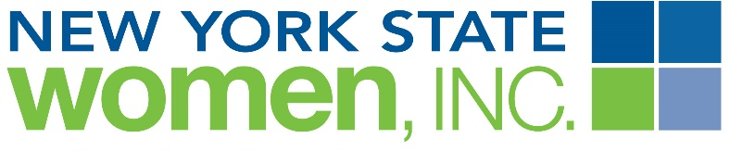 TRIVIA

1. What Region are we? | 2. What are the Chapters in our Region? | 3. NYSWI is a hierarchy, broken into three parts. What are they? | 4. Can a member vote at State Board Meetings?
5. Can a member vote at State Annual Conference? | 6. What is the Mission of NYSWI? | 7. What does PPD stand for? | 8. What is GLEF?
9. Who is the Current State President? | 10. Where is the 2016 Annual Conference being held? | 11. What is the Nike? | 12. What year was BPW started? What year did BPW become NYSWI?
13. Does MV Chapter have a Facebook page? | 14. What can you do on the State Website? | 15. What Girl Scout Badge did BPW/NYSWI help to create? | 16. What game is the Reality Store modeled after?

